CS330 Project Proposal (Revised)

Sarah Nikolaus

04/10/2023

For my project, a lot of consideration went into exactly what scene I wanted to recreate and how I wanted to use my knowledge of OpenGL to do so. The scene I chose is a plantation home. I’ve changed my mind due to the difficulties of this couse, but I believe I can get this design to work.

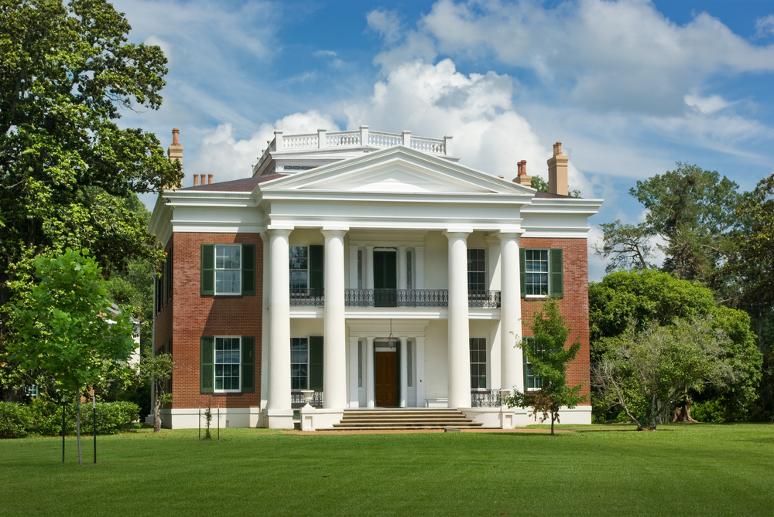

This image will include the following shapes while designing and recreating this image: planes for the marble porch, cylinders for the columns of the porch, cube for the house and columns for trees. The challenges I am seeing with this will be the steps, and trees/plants, but I will do the best that I can. I will also probably add some additional shapes for the face of the house, floor and porch ceiling, but I am not sure yet if that is a definite decision with the design.